March 27, 2012
Abolitionist Movement

- Distribute a blank map of the United States.
- Show a video clip about the abolitionist movement
  - The History Channel: The Abolitionist Movement: http://www.history.com/videos/abolition-and-the-underground-railroad#abolition-and-the-underground-railroad
- On the back of the blank map of the U.S., students record people, events, and places identified in the video clip.
- After viewing the video, students work with a partner to explain what they know about the people, events, and places identified in the video clip.
- Each partnership joins another partnership, forming a group of four students who collaborate about their findings.
- Distribute one piece of butcher paper and markers to each group.
- Students create a graphic organizer about the abolitionist movement. In the center of the organizer, students write the words “abolitionist movement”.
- Each group writes connections between “abolitionist movement” and the people, events, and places they identified from the video clip.
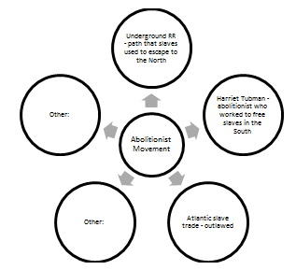
- Project a blank map of the United States. Facilitate a discussion with students to identify geographic areas impacted by the people, events, and places where abolitionist activities took place. Students record ideas, mark location, etc. on their blank map of the U.S. during the discussion.
  - What have been the contributions of significant political, social, and military leaders of the United States related to the abolition of slavery?
  - How did the abolitionist movement develop?
  - What areas of the U.S. were first to embrace the idea of the abolishing slavery?
  - Which areas of the U.S. were resistant to freeing their slave?
- Divide students into six groups.
- Distribute Handout: Abolition Word Association (1 per group).
- Assign groups a number 1-2-3-4-5-6 and explain they are responsible for completing a word association graphic for only the words in their group’s box.
- On butcher paper, each group draws a colorful “graffiti illustration” and writes complete sentences to summarize the relationship among the group of words they are assigned. The graffiti illustration should include the significant date or dates that are related to the group of words.
- Students post their graffiti illustrations/sentences.
- Students form new Gallery Walk Groups - including one member from each of the prior working groups. Each NEW group will have a representative from group 1, group 2, group 3, etc.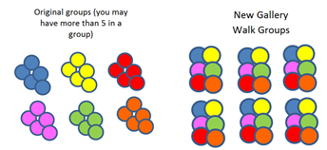
- As these new groups rotate to each visual presentation, the member who worked on that presentation explains the relationships identified in the visual representation.
- Students return to the original working group for discussion.
Facilitate a discussion among group members.
  - What have been the contributions of significant political, social, and military leaders of the United States related to the abolition of slavery?
  - How did the abolitionist movement develop?

