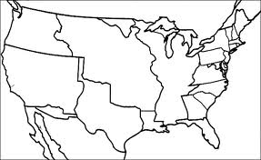
Vocabulary

Acquisition:__________________________________________________________________________________________________________________________________

Annexation:__________________________________________________________________________________________________________________________________

Cession:_______________________________________________________________________________________________________________________________________

Notes
The Louisiana Purchase
Florida Annexed
Texas Annexed
Oregon Country
Mexican Cession | Mexican Cession:  Treaty of Guadelupe Hidalgo:  Mexican-American War:
The Gadsden Purchase
The Purchase of Alaska

