Industrial Revolution Webquest

Watch this video: https://www.youtube.com/watch?feature=player_embedded&v=3Efq-aNBkvc
- What is the Industrial Revolution?

Why did the Industrial Revolution Start in Great Britain?
- The Industrial Revolution began in Great Britain for many different reasons such as having geographical advantages, methods of transportation and communication, and the support of a colonial empire. Using the resources below, answer the following questions in your packet and determine the significance of each as a cause of the Industrial Revolution beginning in Great Britain.

- Define the term: "factors of production" http://en.wikipedia.org/wiki/Factors_of_production

Watch this video: http://ttc.alder.k12.oh.us/SafeVideos/Video.aspx?id=jOcw7Z-xyyQ

- How did coal and iron play a role in the origins of the Industrial Revolution in Great Britain?

- What geographical feature played a role in the transportation of natural resources?

Watch this video: http://ttc.alder.k12.oh.us/SafeVideos/Video.aspx?id=MEymUbVrbgw

- What role did the steam engine play in the Industrial Revolution?

- Closing Question: In your opinion, what factor do you feel played the biggest factor in the Industrial Revolution beginning in Great Britain? (Make sure to explain your answer)

Industrialization and Conflict in America: 1840–1875 is an article that describes aspects of the Industrial Revolution from the human point of view. Manufacturing, inventions and economic growth had a distinct impact on society. These changes altered the way people perceived the world in which they lived. This impact was most evident in the nineteenth century emphasis on family, nature and art. After reading the essay, answer the following questions:
- According to the article, from which two countries did most people emigrate during this period of the Industrial Revolution?
- According to the article, which two inventions helped the spread of industry?
- According to the author, why did people want to escape urban, industrial areas?
- How does Thomas Cole's painting, The Oxbow, represent a reaction to the Industrial Revolution? Do you think that it is a positive or negative reaction?
- How did industrialization influence westward expansion?
Factory Work
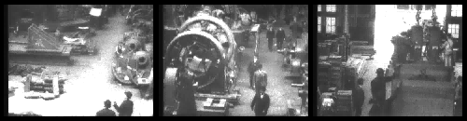
Factory Time Table
- How many hours per day did workers average?
- What hours did the factory operate from March 20 through September 19?
- What hours did it operate from September 20 through March 19?
- Why were the workers' hours different at different times of the year?
- How is the Lowell Mill work day different from most work days today? Which would you prefer?
http://www.schoolshistory.org.uk/IndustrialRevolution/womenandchildren.htm#.UUh_rzeS9QU
- What roles did women play in the Industrial Revolution? How does that differ from today?
Lewiston Mill Rules
Some of the rules at Lewiston Mill are similar to rules at work today, and many are different.
- What is one rule that is similar to today?
- What is one rule that is different from today?
Children at Work
- Choose one of the following children and read about his/her experiences working in a factory. Based on what you read, list at least three reasons why you would not want to work in a factory under similar conditions.
David Rowland
Joseph Herbergam
Hannah Brown
Elizabeth Bently

Industrialization's Impact on People's Lives

Smithsonian Interactive: Family Life
- View the artifact slideshow and read about each one. Pick three to describe how they represent industry's impact on the Lynch family.
Smithsonian Interactive: Living by the Clock
- Read "1700-1820: Marking Time." What did people use instead of clocks before the Industrial Revolution?
- Read "1880-1920: Mechanizing Time." What did race horses have to do with the Industrial Revolution?
- Read "1880-1920: Synchronizing Time." What invention changed the way people begin their day?

Inventors and Inventions

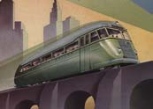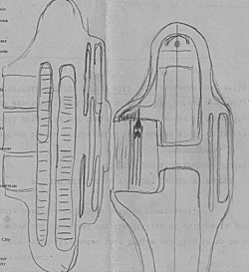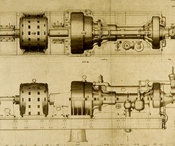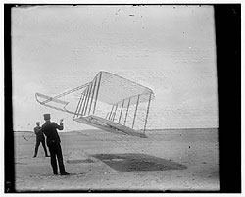
Thomas Edison
- Watch the Edison film linked above. Think about evidence of technology or industry. Give at least two examples of how the film represents the Industrial Revolution.

The Wright Brothers
- This newspaper article introduces readers to the Wright Brothers. Examine the cartoon and explain what is meant by the caption "Father Time Ushers in a New Age."
Alexander Graham Bell
- These sketches by Bell are of the first telephone. The inscription states: “As far as I can remember these are the first drawings made of any telephone or instrument for the transition of verbal utterance by telegraph." Based on the drawings, explain how the first telephone worked.
Mechanical Drawings

Pick your favorite three drawings and answer the following questions for each item.
- What does the item do?
- How did it change they way things were done?
- How would accomplishing tasks have been different before the item was invented?

Capitalists/philanthropists
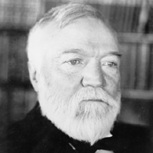
Andrew Carnegie
- What industry is Carnegie known for influencing?
- How did Carnegie contribute to society?

John D. Rockefeller
- What was Rockefeller's first business?
- In what other industry was Rockefeller involved?
- What was his philanthropic (charitable) impact?
- Why did some people believe that Rockefeller had a negative impact?
- In what ways did he have a positive impact?
- Explain why you think his overall impact was either positive or negative.

Industrialization and Conflict in America: 1840–1875
David Jaffe, The Metropolitan Museum of Art
Northern manufacturing extended the use of power-driven machines to a wider range of commodities in the middle decades of the century. By 1860, the United States was second only to Great Britain and France in manufacturing. Stationary steam engines powering advanced machinery allowed factories to set up in the nation's largest cities (1999.396). Affordable books and color prints from the new printing presses disseminated new fashions and ideas connecting urban and rural, East and West. By 1850, nine out of every ten adult white Americans could read, and millions bought books. Women in particular became prodigious readers, as well as the authors of many books and magazine articles (17.104). The nation's population nearly quadrupled between 1814 and 1860, to over 31 million, swelled by an influx of immigrants. Fleeing the potato famine in Ireland and revolutionary turmoil in the German states, foreign-born workers increasingly replaced native-born labor, toiling in factories and crowding into the working-class sections of expanding cities.
The telegraph (invented by Samuel F. B. Morse in 1844), and then the railroad, knit together the regions; the transcontinental railroad was completed in 1869. City merchants built stores opulent enough to be dubbed "palaces of consumption." Urban elites competed in a rivalry over the status of their cities, commissioning public sculptures of the nation's leaders and heroes, therefore providing opportunities for sculptors (97.13.1). The availability of factory-produced goods such as parlor suites of furniture made the trappings of success affordable to the middle class. New forms of manufacture emerged: arms manufacturers and Connecticut clockmakers turned to standardized parts to speed production.
The rapid shift from an agrarian to industrial economy and the growth of the business sector, with their attendant social and economic dislocations, spurred the development of a powerful ideology in which private and public spheres were considered antithetical. The domestic sphere, the realm of home and family, no longer a site of production as in the eighteenth century, would now be seen as a haven against the impersonal, competitive forces of capitalism (66.242.27). Middle-class women would (and were expected to) retire from the workforce to their proper sphere and attend to their primary duties-child rearing and homemaking (28.148.1). This public/private divide was echoed in an idealization of nature and the rural against the noisome, polluted city and its expanding immigrant population. American architect and landscape designer Andrew Jackson Downing (1815–1852) proclaimed the home a "powerful means of civilization" and a remedy for social evils. In his many popular publications, including The Architecture of Country Houses (1850) and Horticulturalist Magazine, often illustrated by architect Alexander J. Davis (1803–1892), Downing recommended the building of country homes where one could cleanse the soul by escaping the psychologically and physically unhealthy aspects of urban life. Reflecting many of Downing's ideas, the first suburban developments aspired to unify nature and architecture, offering a semi-rural retreat from blighted industrial areas (24.66.67).
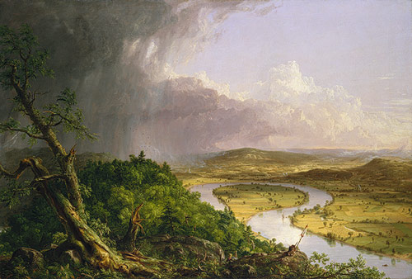
The Oxbow, 1836
Thomas Cole
Meanwhile, America's artists, such as Thomas Cole (1801–1848), founder of the Hudson River School, exalted the national landscape in the midst of its very transformation (08.228). Natural wonders such as Niagara Falls (62.256.3) or wilderness areas such as the Hudson River Valley were popularized by the Hudson River School artists, and increasingly became accessible to travelers and tourists. The virtual nature worship indulged by American artists was nowhere more extremely expressed than in the intimate yet highly objective stipple watercolor style applied to still life and landscapes by American followers of the English critic John Ruskin (1819–1900), whose "truth to nature" aesthetic philosophy gained wide attention during the Civil War era (82.9.1). American genre painters focused on a nostalgic view of displaced American types (33.61). Some cultural commentators of the changing American landscape, like Cole, offered a pessimistic view of the changes wrought by technology; while other painters and writers joined most Americans in a celebration of national progress. Closer to home, urban planners and landscape architects such as Frederick Law Olmsted (1822–1903) and Calvert Vaux (1824–1895) brought nature into the city by building urban parks such as New York's Central Park; Vaux went on to design both The Metropolitan Museum of Art (1874–80) and the American Museum of Natural History (1874–77).
The dynamism of western expansion extended across the Plains to the Pacific Coast, accompanied by the continued removal of Native Americans from their lands and, in 1846–48, war with Mexico. Great finds of precious metals in the American West (72.3) transformed luxury goods, such as gold and silver jewelry. The annexation of western territories doomed earlier political compromises on the extension of slavery. Accelerated industrialization only accentuated sectionalism and the differences between North and South. Southern planters grew increasingly dependent upon slave labor for massive amounts of cotton production (the South accounted for two-thirds of the world's cotton production in 1850), which fed the factories of the North and Great Britain. Slavery's extension into western lands caused a great forced migration of African Americans. Debates over the future extension of slavery fractured the existing national party system along regional lines. The election of Republican Abraham Lincoln in 1860, with his vision of new lands being free of slavery, induced the southern states to secede from the Union, and the horrendous Civil War between North and South ensued. The North triumphed after four long years, due to its greater economic, material, and demographic resources. The era of Reconstruction introduced a period of debate over the political and economic rights of freed slaves (1979.394) and the role of federal power in the reunited states. The Civil War and its aftermath provided an opportunity for artists and photographers in the illustrated press and sculptors in the public sphere to commemorate the heroism and sacrifice of Abraham Lincoln and the common soldier alike.
Jaffee, David. "Industrialization and Conflict in America: 1840–1875". In Heilbrunn Timeline of Art History. New York: The Metropolitan Museum of Art, 2000. http://www.metmuseum.org/toah/hd/indu/hd_indu.htm (April 2007)

